Class
Of
‘22
MAKE IT ALL ABOUT YOU
This year we are asking that if possible, you order your ring online
Prices starting at $199
NATURAL
BLING
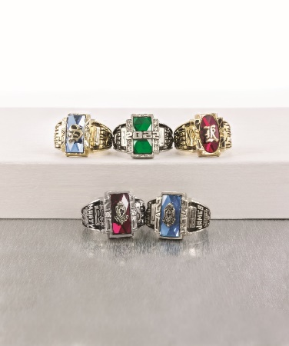
VARIETY


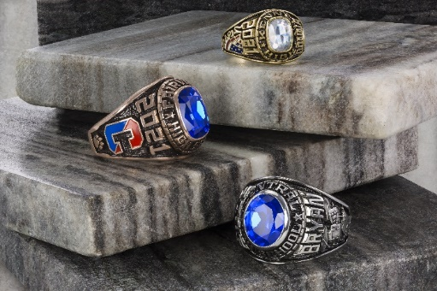
3524 Youree Dr. Shreveport, La 71105
318-865-0409
Don’t let COVID stop you from getting this tradition and memory
Go to graduatesalesyouree.com to place your order
VARIETY
JOURNEY
LEGEND
TRADITIONAL

